**VClass User Guide**

**Login and register to get started**

You will be automatically directed to a login page when you first load the website.

Enter your Email and password in the input boxes provided or click the register button if you have not yet created an account.

If the register button is clicked, then you will be redirected to the register page. Please enter your details to get started.

**Add and create new classes**

If you are a new user, you will not have any classrooms added to your homepage yet. To add a new class, please click the add class icon.

Depending on if you are a teacher or a student you will either be able to add a new class or to create a class.

**Teacher: Creating a class**

Enter the class name of the class you wish to create in the input box provided. Then click the create class button.

Once a class is generated it will be added to your homepage and you will receive a unique class code. Please share this code with your students, as students access the class through this class code.

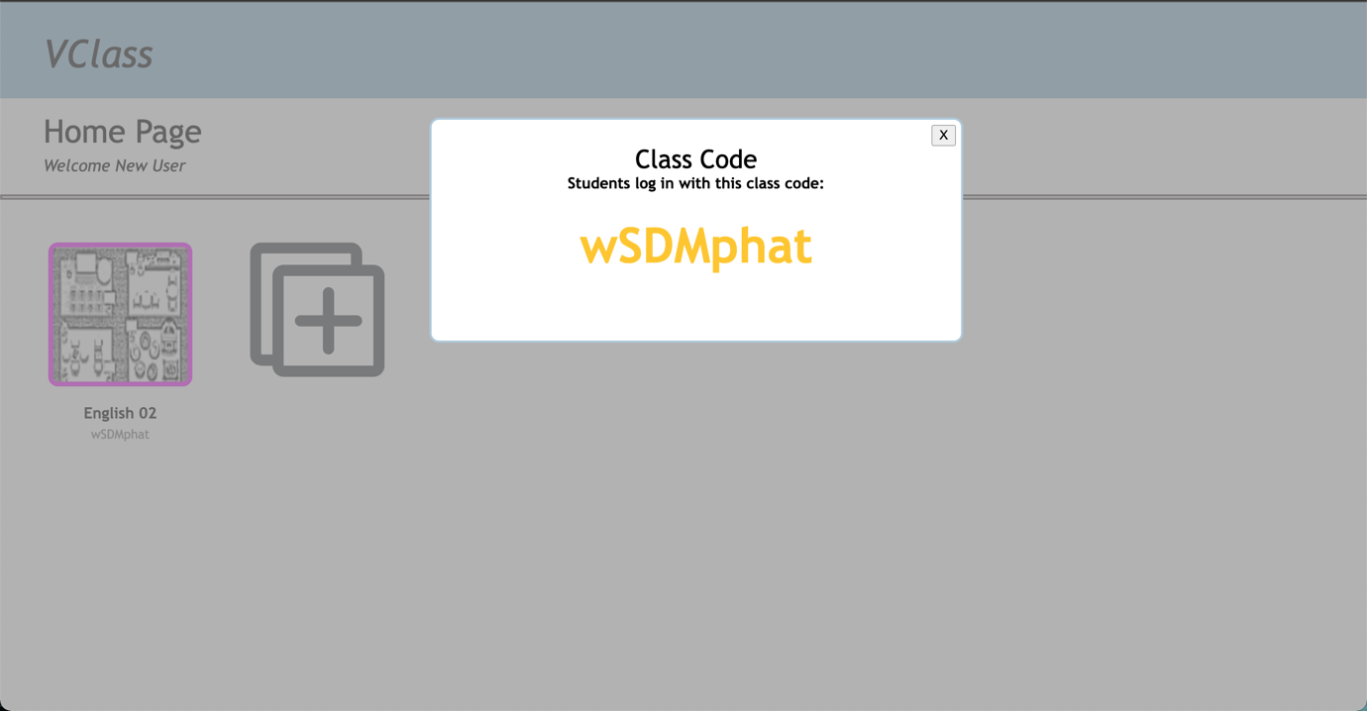

**Students: Adding a class**

Enter the unique class code received from your teacher in the input box provided. Then click the add class button. This will add the new class to your home page display.

**Joining a class**

When one of the classroom images are selected, you will be taken to a join class page. Here you will be able for camera permission and will be able to input your nickname to be used within the classroom and also the work you will be doing. These will be displayed along with a livestream of your computer camera.

There is an option to turn the camera on and off at any moment.

**Moving around and interacting with the virtual classroom**

Once you have entered the classroom you are able to explore and move around! Either use the arrow keys on your keyboard or the keys w,a,s,d.

**

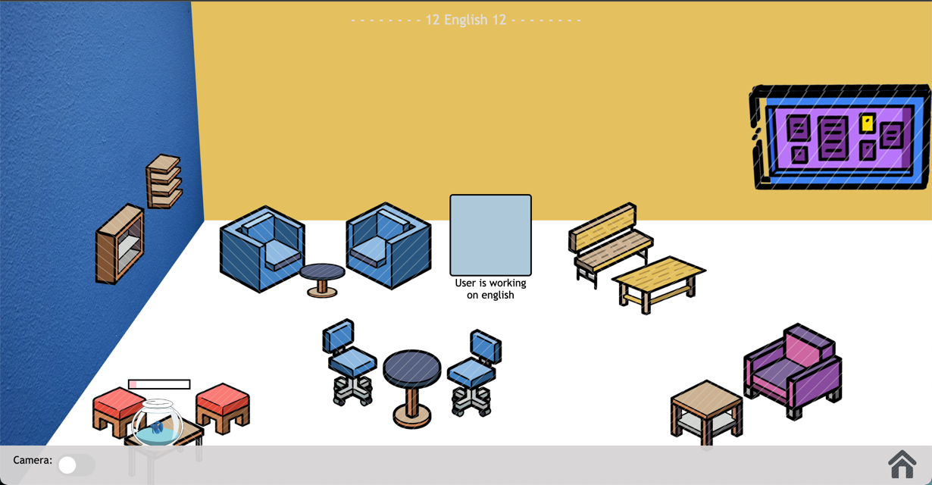

**Interacting with the fish**

If your user is close enough to the fish tank, you are able to click on it to feed the fish and improve the progress bar!

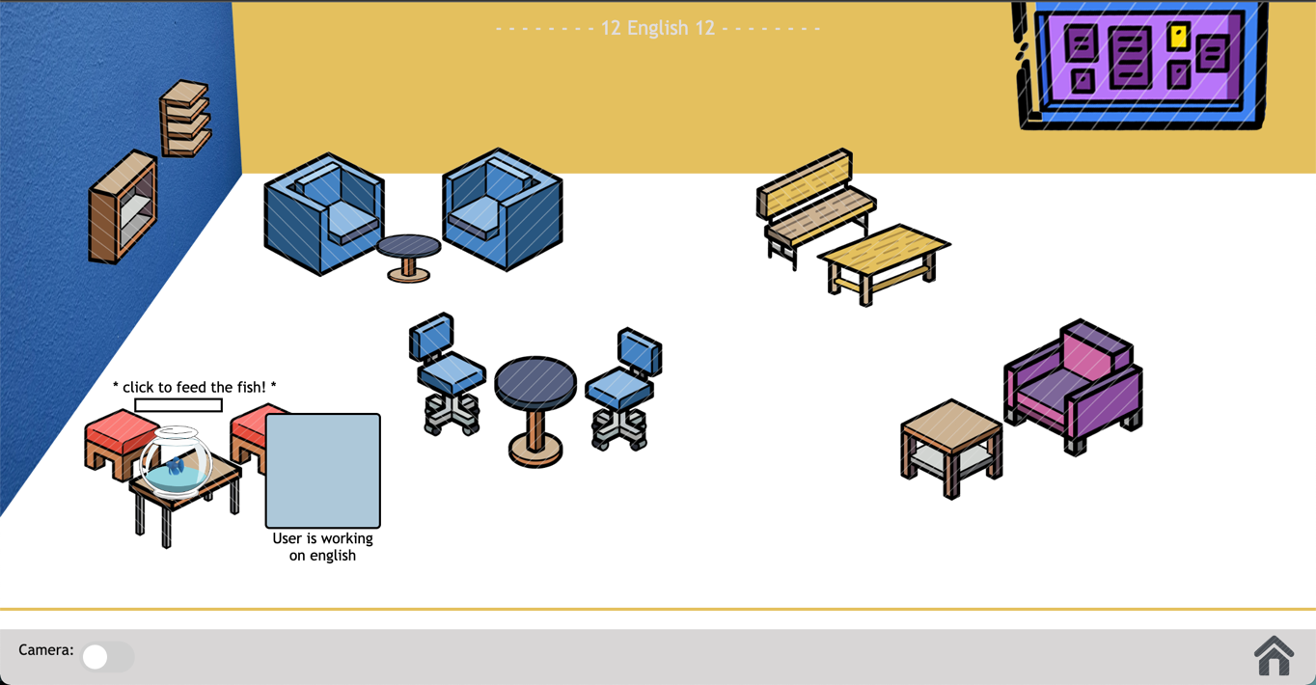

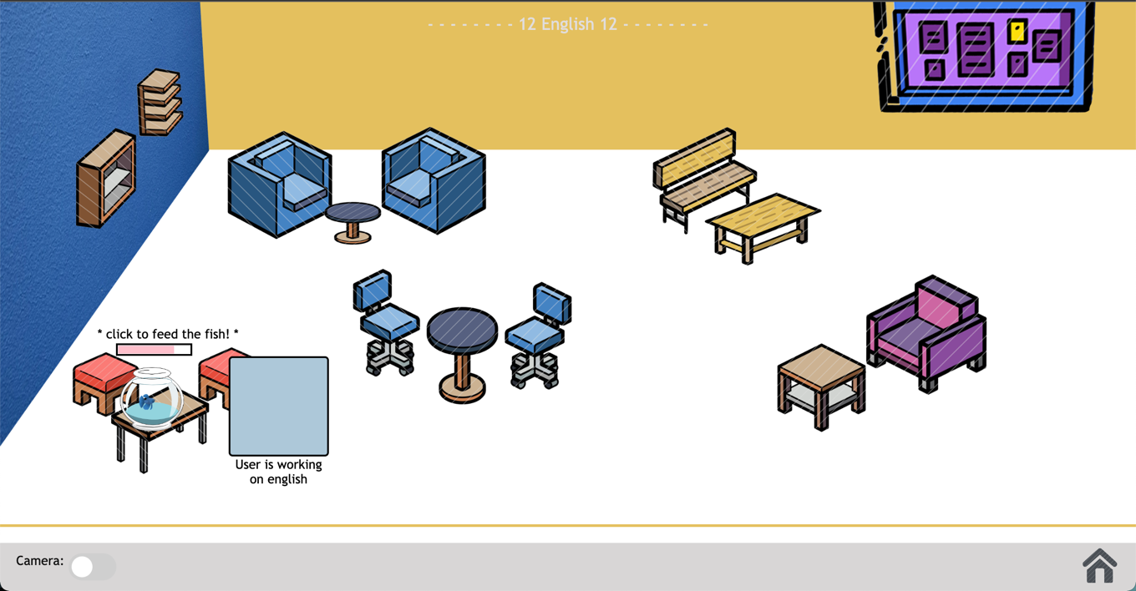

**Interacting with the pinboard**

Move your user to the class pinboard to be able to access the class forum. Just click on the pinboard image.

Looking at posts:

Creating a post:

To create a post, click on the create post button. You are then able to enter the title of your post and the content to post it onto your class pinboard!

**Listening to music**

Move your user close the stereo display to listen to music. The closer you get the louder the music becomes.

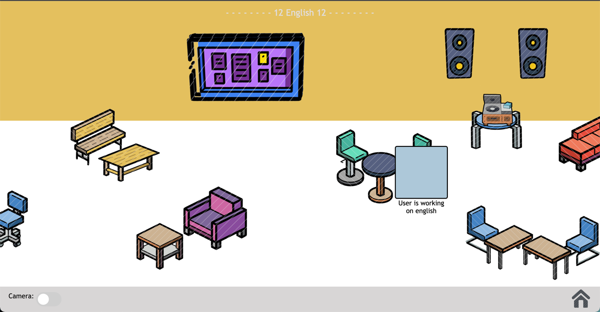

**Returning to the home page**

Find the home image icon on your screen to return back to your homepage.

